Name: A.Lakshmi Likitha Course Code: ITA0330
Reg No: 1929472132 Course Name: Mobile Computing
Slot: D

Experiment 4: Mobile Network Protocol Stack Diagram

Aim: To create a visual representation of the key elements of mobile network protocol stacks using Figma.
Procedure:
- Open Figma and create a new design frame.
- Add a title, “Mobile Network Protocol Stacks”.
- Draw separate sections for the Mobile Device, Radio Access Network (RAN), and Core Network.
- Add protocol labels such as TCP/IP, RRC, PDCP, RLC, MAC, PHY, and NAS.
- Connect the sections using arrows to represent communication between network layers.
- Apply suitable colors and arrange the protocol layers clearly.

Output:
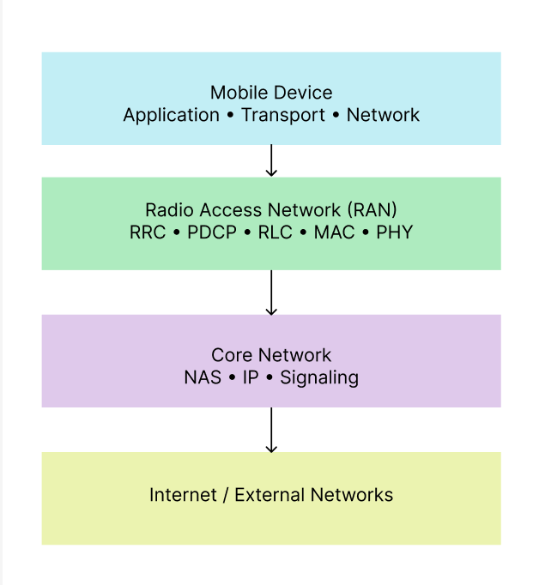


Result: A visual diagram of mobile network protocol stacks and their key components was created successfully.

